Question 1:
What is the difference between a host and an end system? List several different types of end systems. Is a Web server an end system?
Host vs. End System
There is no difference between a host and an end system. The two terms are used interchangeably in computer networking to refer to the devices connected to the Internet at its edges. Hosts (or end systems) are where applications run, they both refer to any device connected to a network that can send or receive information and is typically the source or destination of a message. The core of the internet (routers, switches) is designed to facilitate communication between these "end systems."
Types of End Systems
End systems can be broadly categorized into two types:
- Clients: These are devices that request and receive information from servers.
  - Laptops
  - Desktop computers
  - Smartphones
  - Smart TVs
- Servers: These are devices that store and provide information to clients.
  - Web servers
  - Mail servers
  - Game servers
  - Cloud storage servers
Web Server as an End System
Yes, a Web server is a type of end system. It is a computer that is connected to the Internet and hosts websites, providing content to other end systems (clients) when they make a request.
Both devices are at the "edge" of the network, are the ultimate source and destination of the data, and are therefore both considered end systems (or hosts). The primary difference between them is the software application they are running (a client browser vs. a server software like Apache or Nginx).

Question 2:
Why will two ISPs at the same level of the hierarchy often peer with each other? How does an IXP earn money?
ISP Peering
Two ISPs at the same level of the hierarchy will often peer with each other to reduce costs. In the Internet's customer-provider model, a customer ISP pays a provider ISP to gain access to the Internet. For example, a regional ISP pays a Tier-1 ISP to send its traffic to other networks.
However, if two regional ISPs want to exchange traffic with each other, they would normally have to send that traffic "upstream" through their expensive Tier-1 providers. To avoid this cost, they can peer, which means they create a direct connection between their networks. This allows them to exchange traffic directly and for free (a "settlement-free" agreement).
- Redundancy and Reliability: Peering creates additional paths for network traffic. If one path through a transit provider fails or becomes congested, the peering link can serve as a backup route, increasing the overall resilience and reliability of both networks.
- Control: A direct peering relationship gives both ISPs more control over how traffic between their customers is routed and managed, allowing them to enforce quality-of-service (QoS) policies more effectively.
How an IXP Earns Money
An Internet Exchange Point (IXP) is a physical location where multiple ISPs and content providers can come together to peer. An IXP earns money by charging a fee to the ISPs that connect to it. This fee can be based on:
- Port Fees: The cost to connect to the IXP's network equipment.
- Membership Fees: A regular fee for being a member of the exchange.
- Traffic-Based Fees: Less commonly, some IXPs may charge based on the amount of data an ISP sends or receives.
Essentially, an IXP provides the physical infrastructure and administrative services that make it easy and efficient for multiple ISPs to peer without having to manage individual, point-to-point connections with every other ISP.

Question 3:
What is the difference between a virus and a worm?
Virus vs Worm
Both viruses and worms are types of malicious software, but they differ in how they spread and replicate.
- Virus: A virus is a piece of code that attaches itself to another program or file. It cannot spread on its own and requires a host program to be executed. For a virus to infect other files, a user must run or open the infected host file, at which point the virus will run its malicious code and attempt to attach itself to other files on the system.
- Worm: A worm is a standalone malicious program that can self-replicate and spread on its own without requiring a host file or user interaction. Worms exploit vulnerabilities in a network to automatically move from one computer to another, often consuming network bandwidth and slowing down or crashing systems in the process. A classic example is the Morris worm, which exploited a bug in a Unix mail program to spread rapidly.
In simple terms, a virus needs a human action to spread, while a worm does not.

Question 4:
Describe how a botnet can be created and how it can be used for a DDoS attack.
Botnet Creation
A botnet (short for "robot network") is a collection of internet-connected devices, such as computers, smartphones, or IoT devices, that have been infected with malware and are controlled by a single attacker, known as a bot-herder.
The process typically unfolds in these steps:
- Malware Distribution: The bot-herder infects devices by distributing malware through phishing emails, infected websites, or by exploiting software vulnerabilities.
- Device Compromise: Once a device is infected, it silently becomes a "bot" or "zombie," giving the bot-herder remote control over it without the owner's knowledge.
- Command and Control (C&C): All the bots connect to a central command and control server. The bot-herder can then issue commands to the entire botnet from this central location.
DDoS Attack with a Botnet
A Distributed Denial of Service (DDoS) attack aims to overwhelm a target server or network with a flood of traffic, making it unavailable to legitimate users. A botnet is the perfect tool for a DDoS attack because it allows the attacker to coordinate a massive number of compromised devices to launch the attack simultaneously.
Here is how a botnet is used for a DDoS attack on Application-Layer:
- Commanding the Botnet: The bot-herder sends a command from their C&C server to all the bots in the network.
- Launching the Attack: The command instructs the bots to send a flood of traffic (e.g., thousands of HTTP requests or TCP packets) to a single, target IP address or website URL.
- Overwhelming the Target: Because the traffic comes from thousands or even millions of different IP addresses, it's very difficult for the target's security systems to block it. The sheer volume of traffic overwhelms the target server's resources (CPU, memory, bandwidth), causing it to slow down or crash completely, thereby denying service to legitimate users.

Question 5:
Which layers in the Internet protocol stack does a router process? Which layers does a link-layer switch process? Which layers does a host process?
Router
A router processes the Network Layer and the layers below it (Link Layer and Physical Layer). It uses IP Adress.
- Physical Layer: The router receives the raw bits from the incoming link.
- Link Layer: The router processes the link-layer frame to get the packet inside.
- Network Layer: This is the most important layer for the router. The router uses the packet's IP address (which belongs to the Network Layer) to determine the next hop and the correct outgoing link for the packet based on its routing table.
Link-Layer Switch
A link-layer switch processes the Link Layer and the Physical Layer. It uses the link-layer address (like a MAC address) to forward frames between different devices on the same local network. It does not look at the IP address, which is a Network Layer concept.
Host
A host (like your computer or a Web server) processes all five layers of the Internet protocol stack. It uses IP Address, MAC Address, Port Number.
- Application Layer (5): The host runs the application (e.g., a web browser or email client).
- Transport Layer (4): It handles end-to-end communication, managing protocols like TCP and UDP.
- Network Layer (3): It processes the IP address for routing.
- Link Layer (2): It handles the physical connection to the network.
- Physical Layer (1): It sends and receives the raw bits over the physical medium.

Question 6:
Design an application-level protocol to be used between an automatic teller machine and a bank’s centralized computer. Your protocol should allow a user’s card and password to be verified, the account balance (which is maintained at the centralized computer) to be queried, and an account withdrawal to be made (that is, money disbursed to the user). Your protocol entities should be able to handle the all-too-common case in which there is not enough money in the account to cover the withdrawal. Specify your protocol by listing the messages exchanged and the action taken by the automatic teller machine or the bank’s centralized computer on transmission and receipt of messages. Sketch the operation of your protocol for the case of a simple withdrawal with no errors. Use human protocols and TCP connection figure as a reference from slides or book.
Application-Level Protocol for an ATM
This protocol is designed for the secure exchange of messages between an Automatic Teller Machine (ATM) and a bank's centralized computer to handle verification, balance inquiries, and withdrawals. The ATM and the bank's computer will use a reliable transport protocol like TCP to ensure messages are delivered correctly.
Protocol Messages
Messages from the ATM to the Bank are requests. Messages from the Bank to the ATM are responses. Each response contains a status code.
Here are the messages exchanged, along with their format and purpose:
- VERIFY_CREDENTIALS:
  - Sent by: ATM
  - Content: card_number, PIN
  - Purpose: To authenticate the user's card and personal identification number.
- VERIFICATION_RESPONSE:
  - Sent by: Bank Computer
  - Content: status (SUCCESS or FAILURE)
  - Purpose: To inform the ATM whether the user's credentials are valid.
- QUERY_BALANCE:
  - Sent by: ATM
  - Content: card_number
  - Purpose: To request the current balance for the user's account.
- BALANCE_RESPONSE:
  - Sent by: Bank Computer
  - Content: status (SUCCESS or FAILURE), balance (if successful)
  - Purpose: To send the account balance to the ATM.
- WITHDRAWAL_REQUEST:
  - Sent by: ATM
  - Content: card_number, amount
  - Purpose: To request a withdrawal of a specific amount from the account.
- WITHDRAWAL_RESPONSE:
  - Sent by: Bank Computer
  - Content: status (SUCCESS, INSUFFICIENT_FUNDS, or FAILURE), new_balance (if successful)
  - Purpose: To inform the ATM about the outcome of the withdrawal request.
Actions on Transmission/Receipt
- ATM on sending a request: Waits for a corresponding response for a predefined timeout. If no response, it may retry or display a "Network Error" message.
- ATM on receiving a response: Checks the status code. If it's an error, it displays an appropriate message to the user (e.g., "Invalid PIN", "Insufficient Funds"). On success, it proceeds to the next step in the user interaction.
- Bank on receiving a request: Validates the session_token (if present) to ensure the request is part of a valid, authenticated session. Processes the request, updates the database, and generates a response.
- Bank on sending a response: Maintains the session state until an END message is received or a session timeout occurs.
Protocol Sketch: A Simple Withdrawal with No Errors
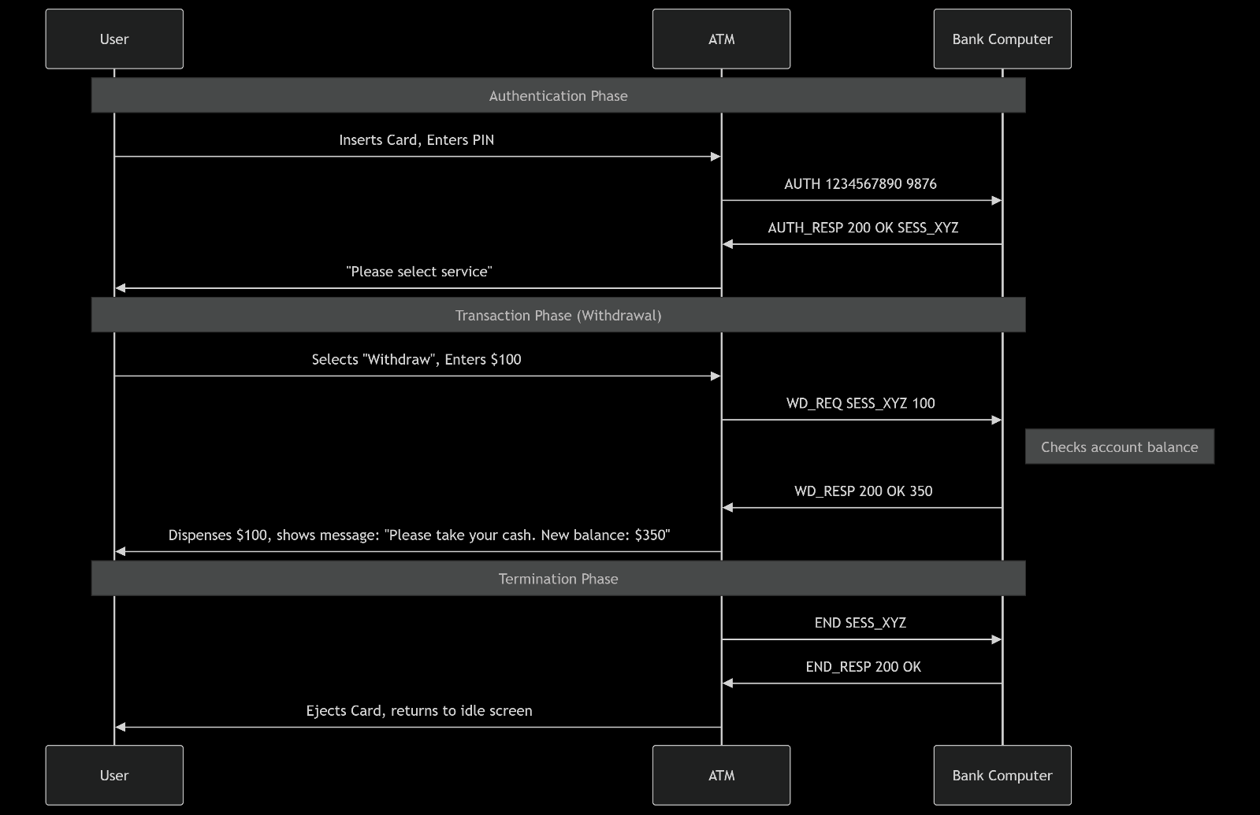

Question 7:
a) Suppose N packets arrive simultaneously to a link at which no packets are currently being transmitted or queued. Each packet is of length L and the link has transmission rate R. What is the average queuing delay for the N packets?
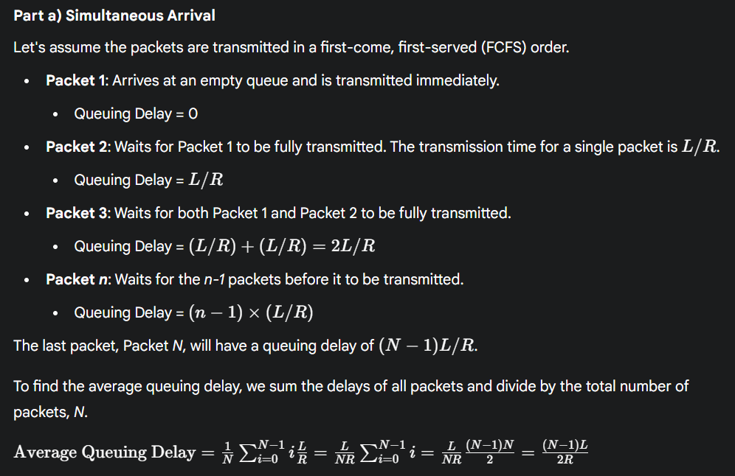
b) Now suppose that N such packets arrive to the link every LN/R seconds. What is the average queuing delay of a packet?
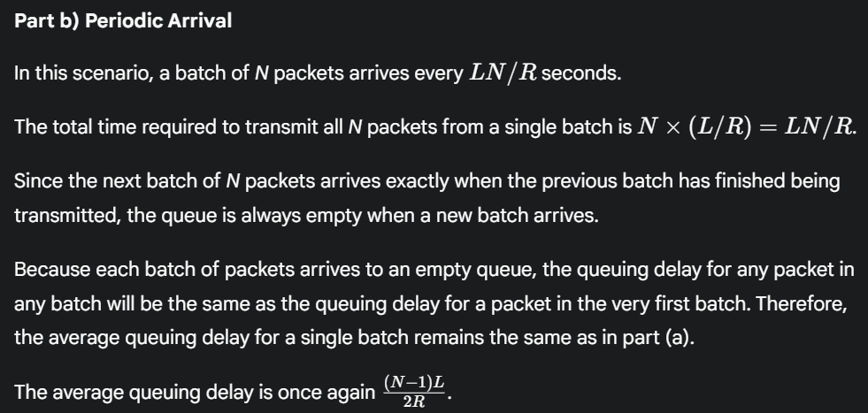

Question 8:
Consider the queuing delay in a router buffer. Let I denote traffic intensity; that is, I=La/R. Suppose that the queuing delay takes the form IL/R(1-I) for I<1.
a) Provide a formula for the total delay, that is, the queuing delay plus the transmission delay.
b) Plot the total delay as a function of L/R.
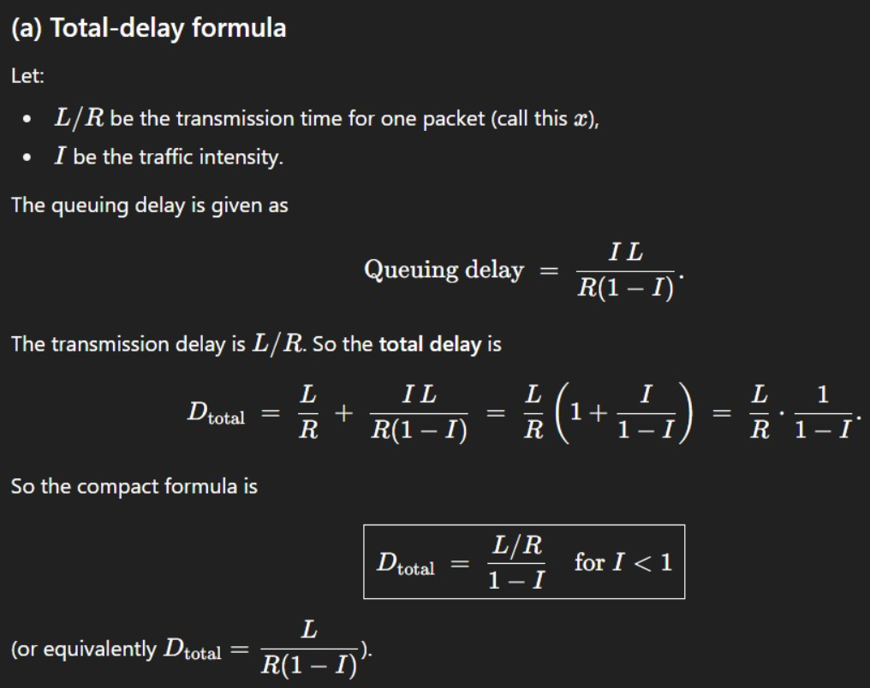
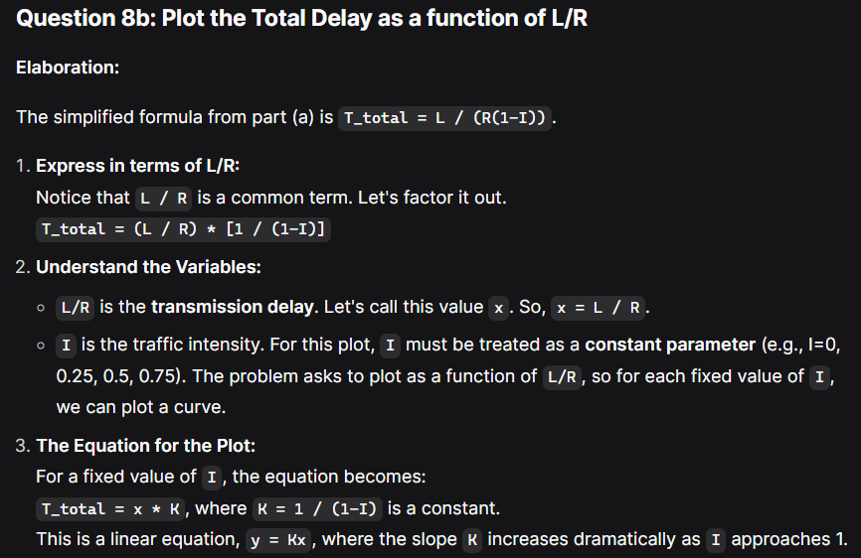
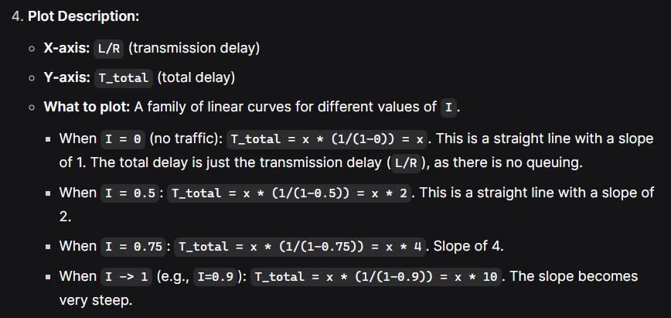
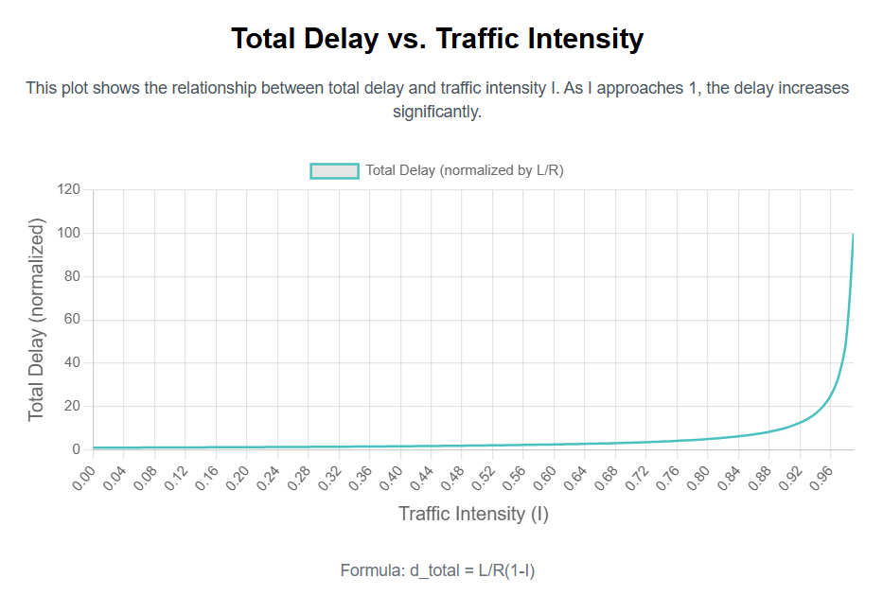
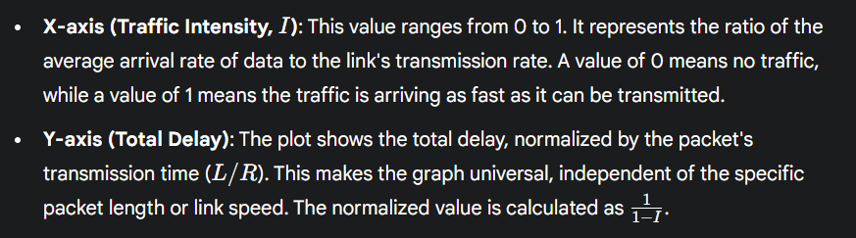
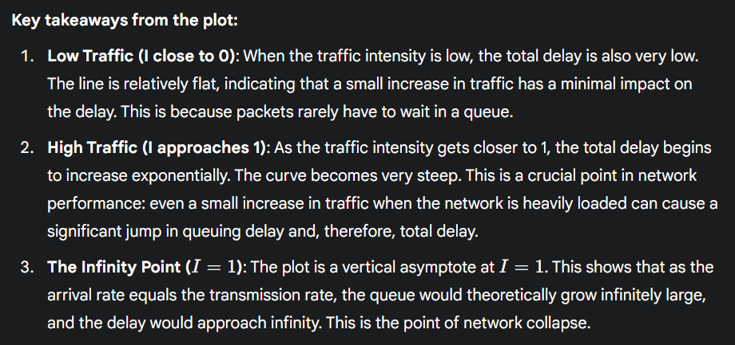
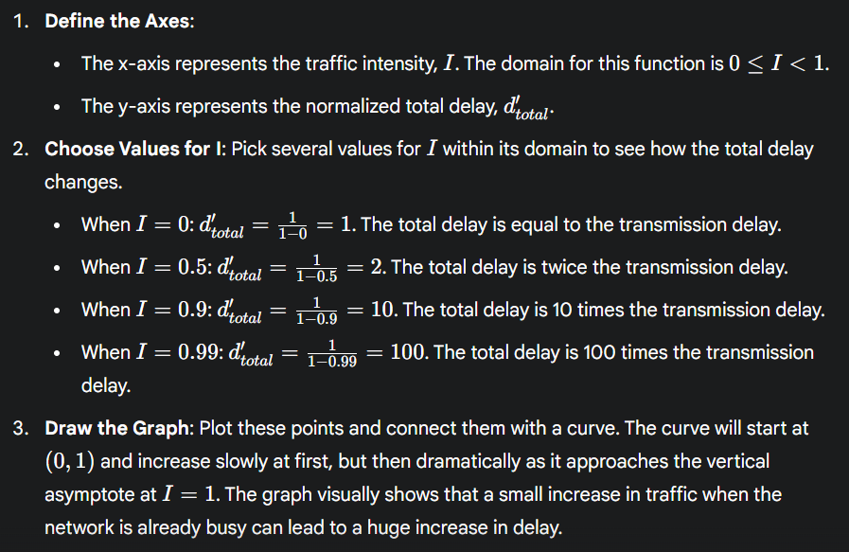
Question 9:
How long does it take a packet of length 1,000 bytes to propagate over a link of distance 2,500 km, propagation speed 2.5*10^8 m/s, and transmission rate 2 Mbps? More generally, how long does it take a packet of length L to propagate over a link of distance d, propagation speed s, and transmission rate R bps? Does this delay depend on packet length? Does this delay depend on transmission rate?
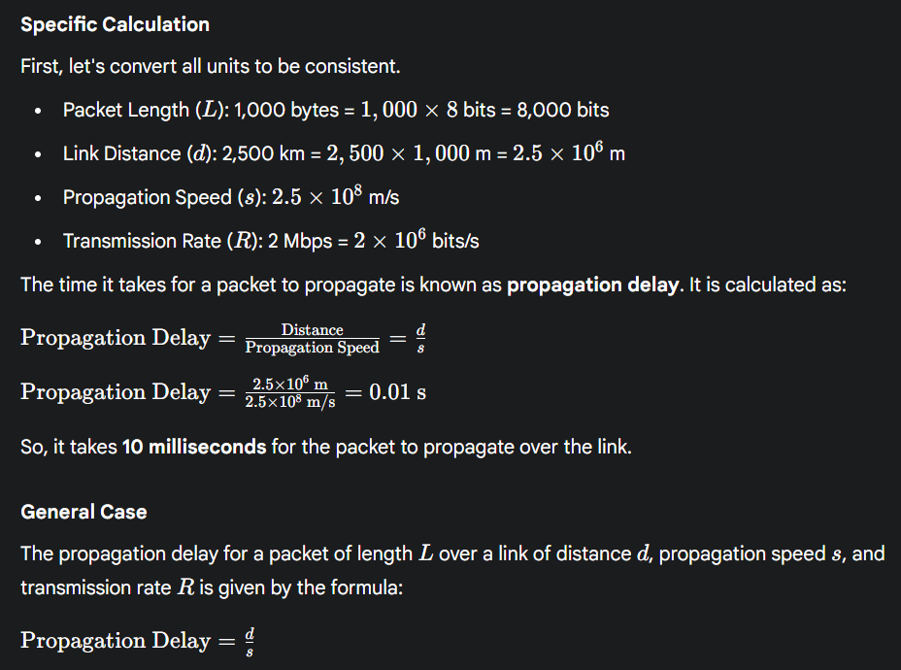
Dependence on Variables
- Does this delay depend on packet length (L)? No. The propagation delay depends only on the physical distance and the speed of the signal, not on how long the packet is.
- Does this delay depend on transmission rate (R)? No. The propagation delay is independent of the transmission rate. Transmission rate determines how long it takes for a packet to be pushed onto the link, which is a separate delay called transmission delay.

Question 10:
A packet switch receives a packet and determines the outbound link to which the packet should be forwarded. When the packet arrives, one other packet is halfway done being transmitted on this outbound link and four other packets are waiting to be transmitted. Packets are transmitted in order of arrival. Suppose all packets are 1,500 bytes and the link rate is 2 Mbps. What is the queuing delay for the packet? More generally, what is the queuing delay when all packets have length L, the transmission rate is R, x bits of the currently-being-transmitted packet have been transmitted, and n packets are already in the queue?
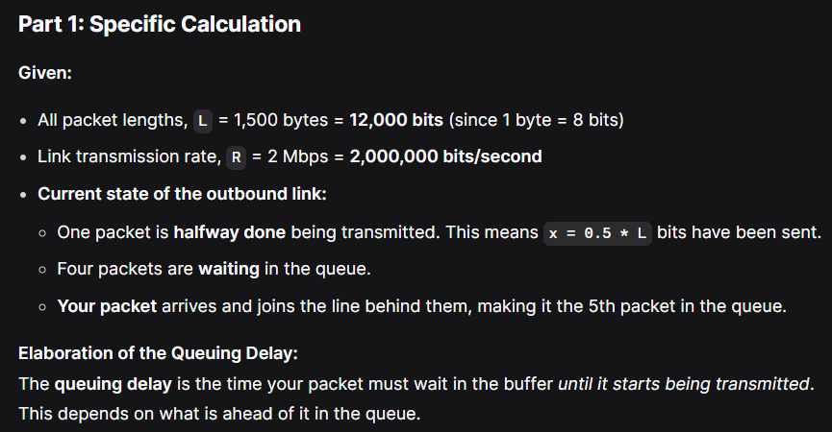
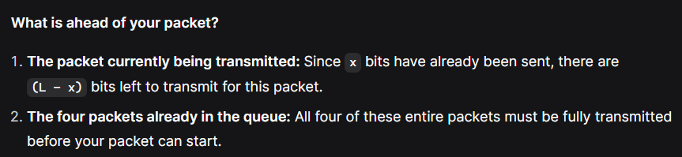
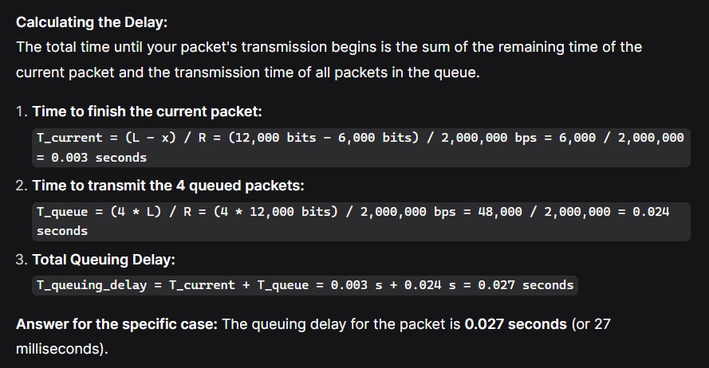
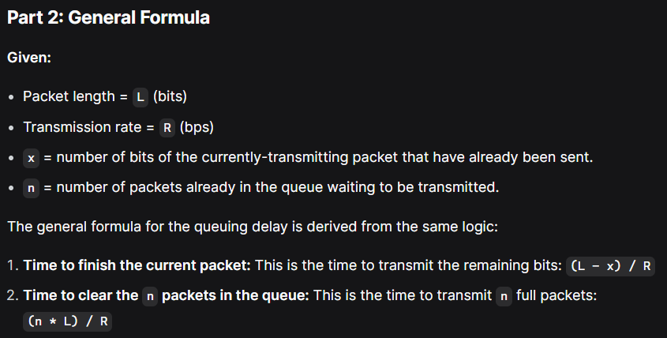
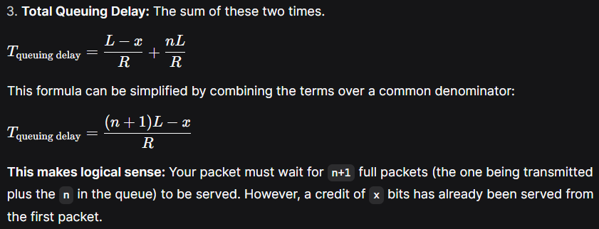
Question 11:
Suppose you would like to urgently deliver 40 terabytes data from Faisalabad to Karachi. You have available a 100 Mbps dedicated link for data transfer. Would you prefer to transmit the data via this link or instead use FedEx overnight delivery? Explain.
